**Second: Write queries that directly answer predetermined questions from a business stakeholder**

Launch MySQL server, I have used XAMPP localhost.

Step1: Create database “fetch_reards”:

Step2: Creation of Tables:

Users:

CPGs table:

Brands table:



Receipts table:

ReceiptItems table:

Step3: Import data from CSV files (user_normalized.csv, brands_normalized.csv, cpgs_normalized.csv, receipts_normalized.csv, receipt_items_normalized.csv) using “Import” feature of MySQL.

Step4: Write SQL queries against your new structured relational data model

**Note: For queries involving data related to a specific month, such as the most recent month or the past six months, the current date has been considered as ‘March 1, 2021’. This is because, after converting the MongoDB milliseconds timestamp to a datetime format from the given JSON files, the latest recorded data falls within March 2021.**

* When considering *average spend* from receipts with 'rewardsReceiptStatus’ of ‘Accepted’ or ‘Rejected’, which is greater?

* When considering *total number of items purchased* from receipts with 'rewardsReceiptStatus’ of ‘Accepted’ or ‘Rejected’, which is greater?

* Which brand has the most *spend* among users who were created within the past 6 months?

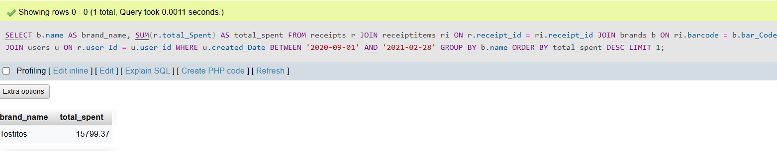

* Which brand has the most *transactions* among users who were created within the past 6 months?

* What are the top 5 brands by receipts scanned for most recent month?

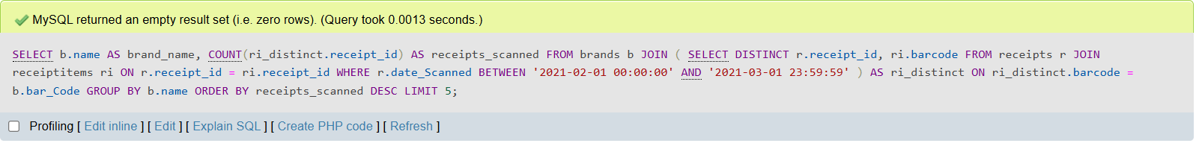

* How does the ranking of the top 5 brands by receipts scanned for the recent month compare to the ranking for the previous month?

